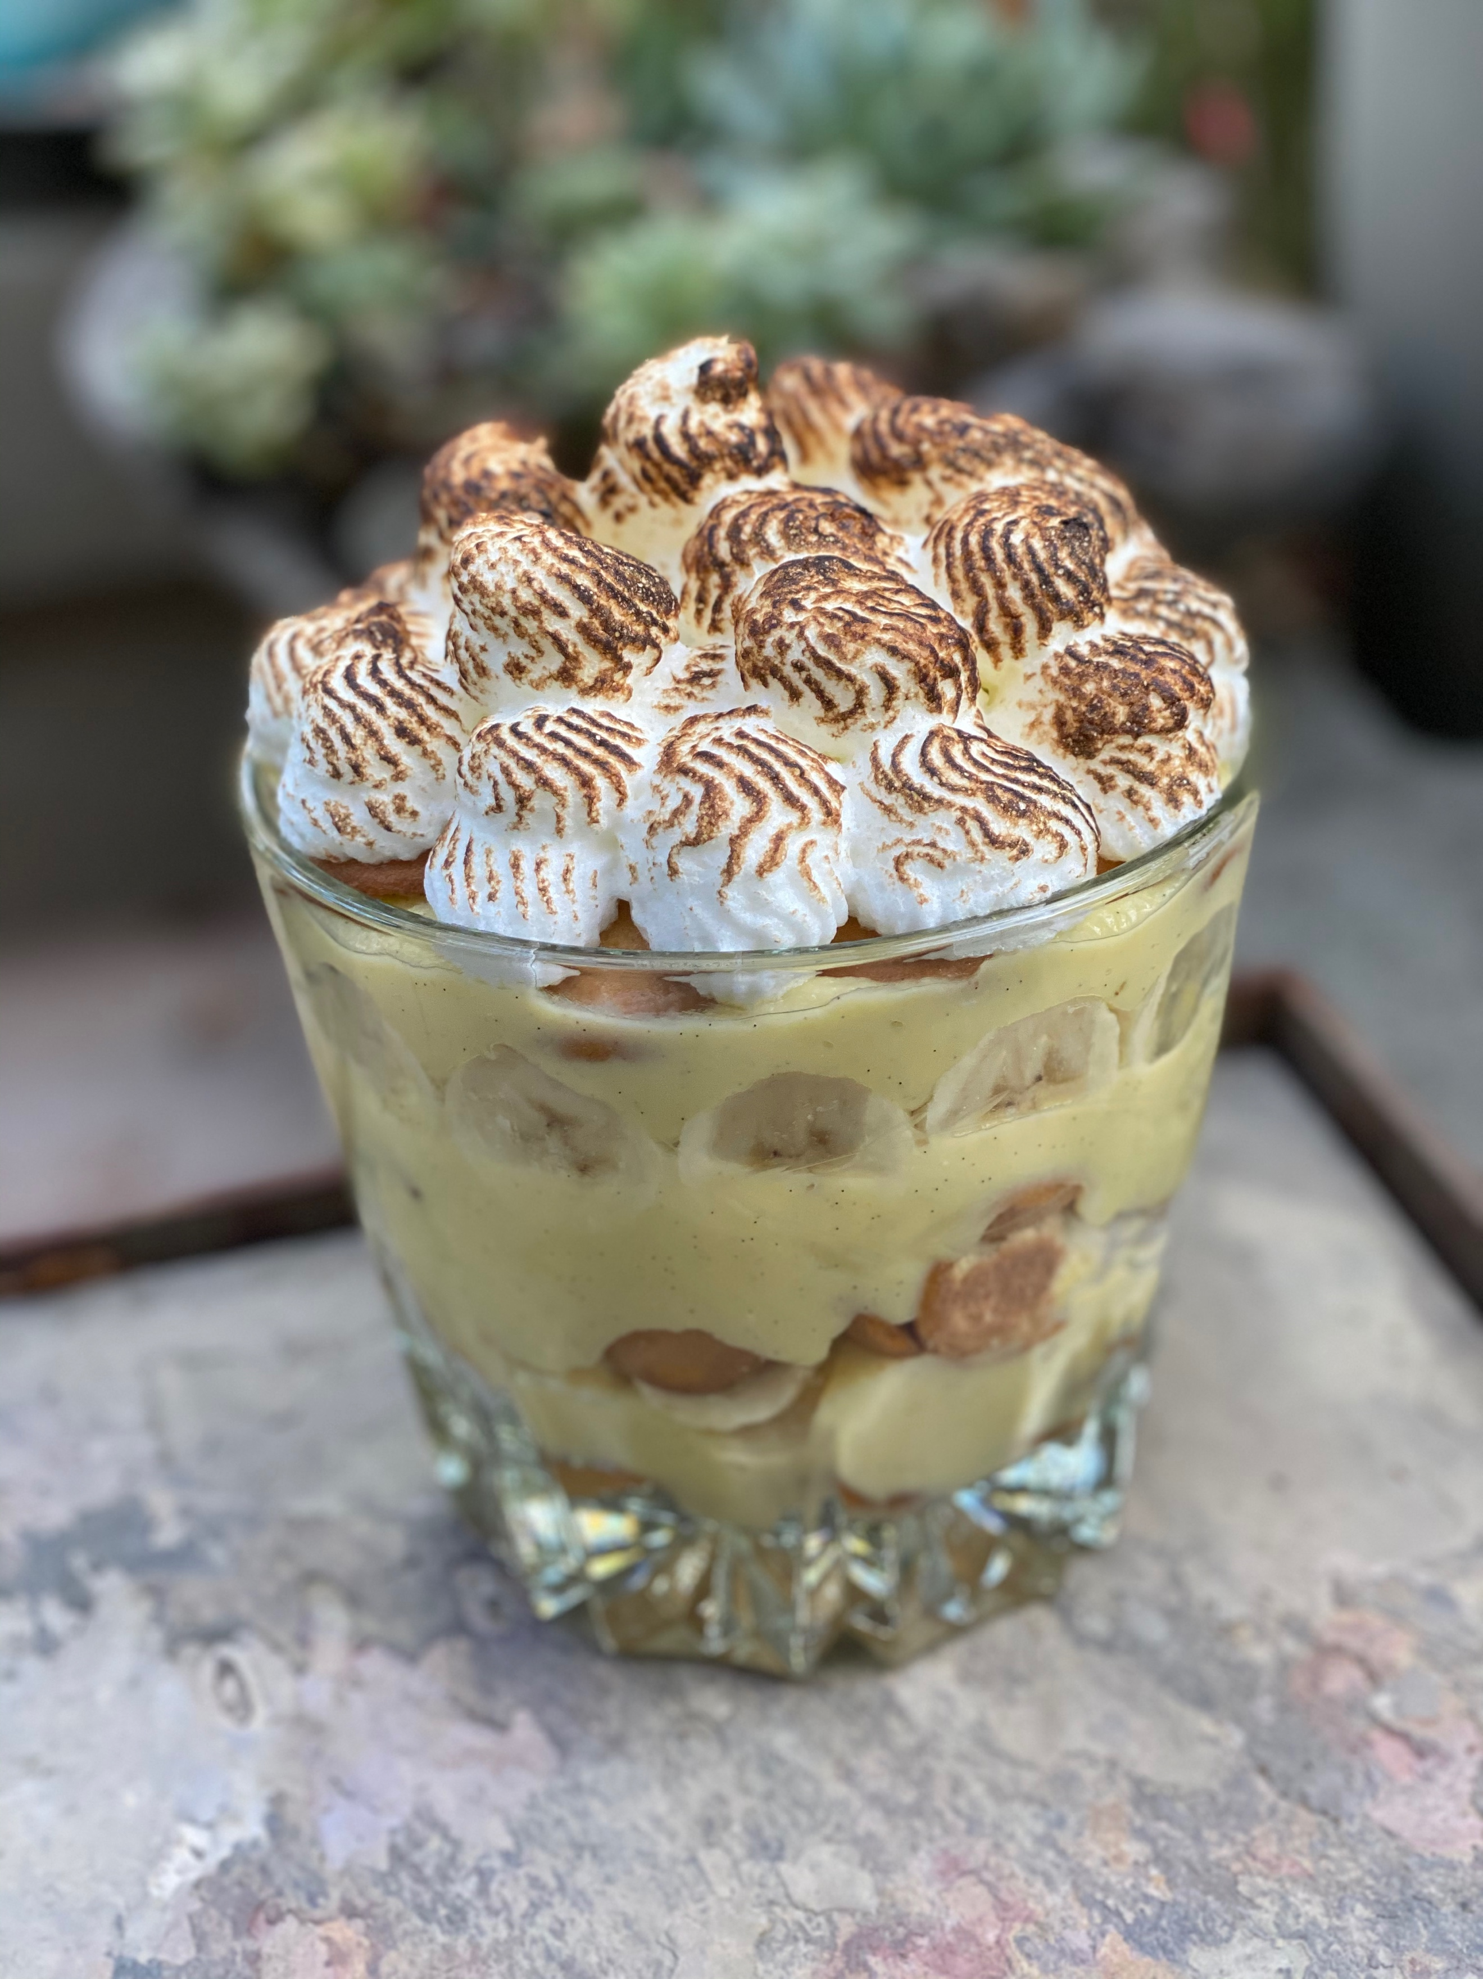
Southern Banana Pudding Trifle

Don’t be surprised at the three main steps into making this iconic dessert. Everything is homemade in this dessert, Yes, you could use ‘Nilla Wafers®, Jell-O® Banana Pudding and Cool-Whip®, but honestly, try to make it from scratch and you will never go back.

One 12 cup bowl
Serves 12 to 14

1 recipe Almond Vanilla Wafers (made a day prior)
1 recipe Banana French Pastry Cream, cooled completely
2 large bananas, sliced thin
1 recipe Pie Meringue, placed into a pastry bag with a star tip
3 tbsp banana liqueur

- Recipes are below for the above items. After you have made everything it is time to assemble your trifle.

- Take a large see through bowl and place a layer of cookies on the bottom. Sprinkle with about 1 tbsp of banana liqueur, then about half of the Banana French Pastry Cream, then one of the slices of banana. Repeat: cookies, liqueur, banana, French Pastry Cream. If you have room in the bowl, top with cookies and then liqueur.

- Pipe meringue on the top. Torch the meringue to complete the look.

: You can make the dessert up to the meringue a day before to the cookies soak in the pastry cream.

Almond Vanilla Wafers

2 baking sheets lined with parchment paper
Oven preheated to 325°F
140 2-inch cookies
Pastry bag with a large round tip

Light and crispy with an essence of almond. Similar to the ‘Nilla® Wafers you enjoyed as a kid… But better. Make these a day prior to use.

1 lb unsalted butter, softened
2 cups granulated sugar
6 large egg whites
2 large whole eggs

1 tbsp pure vanilla extract
1-1/2 tsp sea salt

4 cups all-purpose flour
1-2/3 cups almond flour

- In a mixing bowl fitted with the paddle attachment, cream butter and sugar together until light and fluffy, about 4 minutes. Add egg whites, eggs, vanilla and salt on low speed until blended. The mixture may look separated.

- Add flours together, blending until completely mixed well. Scrap the bottom of the mixing bowl and blend a minute longer.

- Place a few spoonful’s into pastry bag that has been fitted with a large round tip. Pipe mounds about the size of a half dollar. Pipe seven rounds by five rounds. Pipe two sheets and place in preheated oven. Bake until firm (about 12-14 minutes) for a soft cookie, for a lightly crunched cookie, bake until lightly browned on the edges, (about 22-26 minutes).

- Let cool on baking sheet before removing. Pipe two more trays and bake. Cool cookies and leave them in a cool dry place until needed for use.

: If you refrigerate the dough, it will get hard and you will not be able to pipe out of a pastry bag.

Banana French Pastry Cream

Yield: 2 cups

With the essence of a fresh vanilla bean this cream will fill the home with sweet smells. This is a staple in a pastry kitchen. Do not mistake this for vanilla pudding.

12 oz whole milk
1 whole vanilla bean, fresh
1 cup granulated sugar
2 tbsp cornstarch
3 oz whole milk
5 large eggs
2 tbsp unsalted butter, softened
1/2 tsp banana extract

- In a large saucepan place the first milk and a vanilla bean that has been scraped down with the pod and simmer on low heat.

- Meanwhile, in a large bowl whisk sugar and cornstarch together. Set aside.

- In a medium bowl, whisk second milk and eggs. Whisk into the dry mixture, incorporate and set aside until ready.

- With the milk mixture, as it starts to simmer a bit with foam on the sides of the pan, turn the heat off and strain off the vanilla pod, place back on the heat and heat until it boils when this mixture starts to boil whisk the sugar/cornstarch mixture into it without turning the heat off.

- Stirring until it thickens, about 10 minutes. Make sure that the mixture does not stick to the bottom. Take off of the heat. Stir in butter and banana extract.

- Pour onto a cookie sheet to cool faster, and after room temperature. You can make this a day prior to use.

Pie Meringue

Yield: about 1-1/2 cups

This is very simple to make as long as it is not humid outside. Do not try making it when it is raining.

4 large egg whites
1 tsp cream of tarter
1/2 cup granulated sugar

- First wash the bowl and whip very good with hot soapy water and wash the inter top of the mixer as this area traps dirt that could cause you meringue to fall, dry very well. One drop of and oily substance will also make your whites fall.

- Pour the egg whites and the cream of tartar into the bottom of the bowl and place the whip on to a medium speed, whip until frothy.

- Place the sugar into a pourable container and when the whites are frothy without turning the mixer off, pour the sugar into the egg whites.

- Whip to a stiff peak. Place the meringue into a pastry bag. It is ready to use.

