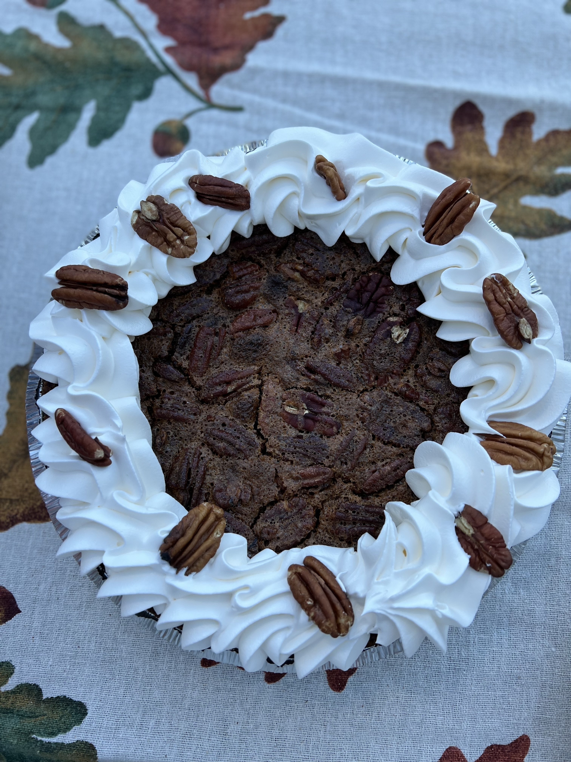
Pecan Kahlua Cream Pie

This is a flavorful Pie with a little “kick!”

Yield: 1 9-inch pie
350°F

1–9-inch chocolate cookie crust
1/4 cup unsalted butter, softened
1/2 cup granulated sugar
1/2 cup brown sugar, lightly packed
3 large eggs
1 cup light corn syrup
1/4 cup Kahlua
1-1/2 cups pecan halves
Whipped cream.

- In mixing bowl with whisk, cream butter, granulated sugar, and brown sugar until blended, add eggs, blending well. Add corn syrup and Kahlua.

- Place pecans into bottom of pie shell. Place on baking rack and pour filling into pan. Push rack into the oven and bake until firm, about 45-50 minutes.

- The filling will look puffy, but it will sink after it cools. Cool completely for 2 hours prior to serving.

- Top with whipped cream and decorate with pecan halves.

