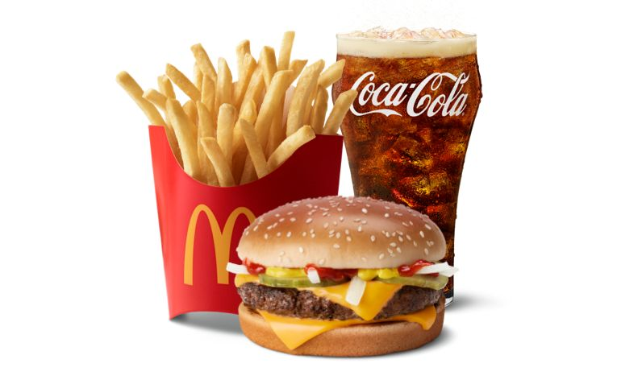
McDonalds Quarter Pounder with Cheese Meal $12.17
Burger
Medium Fries
Medium Drink

Make your own:
Burger
Bun 1 .41
Beef 4 ounces 1.72
Cheddar Cheese 2 pieces .30
Pickles 2 .08
Onions .05 ounce .15
Catsup .05 ounce .17
Mustard .05 ounce .12

French Fries 4 ounces .64
Drink 12-oz Coke .48

Total $4.07

Savings $8.10

