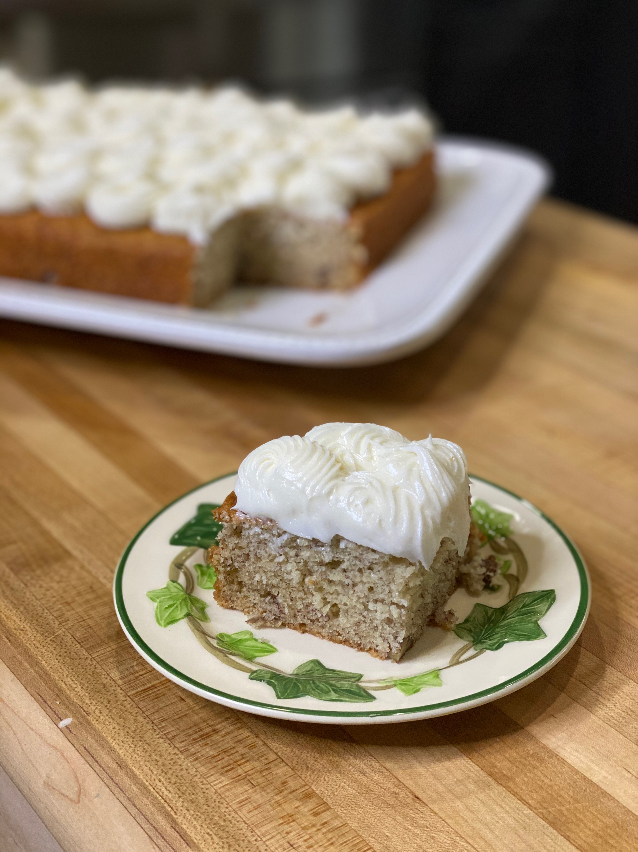
Banana Pecan Cake Bars

For years I would see banana cake mixes in the stores, now you will be hard pressed to find one. I guess the cake mix companies think banana cakes are out of style. I use all of my ripe bananas to make this very moist cake.

Preheat oven to 325°F
9x13-inch baking pan sprayed with non-stick spray
Serves 10 to 12

3 cups cake flour
1 tsp baking soda
1/2 tsp salt
1/2 tsp baking powder
1 cup unsalted butter, softened
2 cups granulated sugar
3 large eggs
2 tsp vanilla extract
1-1/2 cups ripe bananas, smashed
6 tbsp buttermilk
1/2 cup chopped pecans

- In a bowl, combine flour, soda, salt and baking powder. Set aside.

- In mixer bowl, beat butter and sugar until creamy, about 2 minutes. Add eggs one at a time. Add vanilla, bananas and buttermilk. On low speed, combine dry ingredients; mix only until blended, about 3 minutes. Fold in pecans.

- Pour in prepared baking pan. Bake in preheated oven until a toothpick inserted into center comes out clean, 40 to 50 minutes. Cool in pan, on a rack until completely cool.

- Ice with Cream Cheese Icing or a dusting of powdered sugar.

