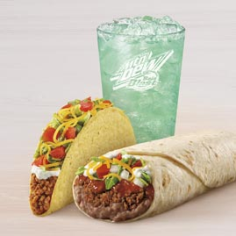
Taco Bell Burrito Supreme Combo $12.39
Taco Supreme
Burrito Supreme
Medium Drink

Taco
Taco shell .30
Taco meat 1.29
Sour cream .21
Cheddar cheese .37
Lettuce .34
Tomatoes .03

Burrito
12-inch tortilla .08
Refried beans .19
Taco meat 1.29
Salsa .08
Onions .17
Tomatoes .06
Cheddar cheese .37

12-oz drink .48

Total for Make Your Own $5.26

Total Savings $7.13

