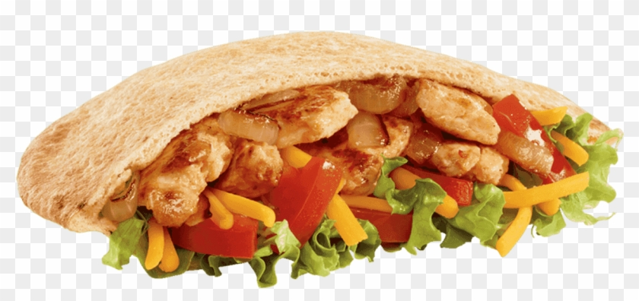

Jack in the Box: Chicken Fajita Pita Meal $11.98
Chicken Fajita Pita
Medium French Fries
Medium Drink

Chicken Fajita Pita
Chicken strips 3 ounces 2.00
Cheddar cheese 2 ounces .56
Lettuce 1 ounce .34 Onions 2 ounces .37
Tomato 1.5 ounces .09
Pita bread .56

Medium French Fries .64
Medium Drink .48

Total “Make Your Own” $5.85

Savings $6.13

