George Geary Culinary Adventures

New Orleans Fall 2023
“The Great Culinary and Historical Tour of New Orleans”
Friday October 13th – Monday October 16th, 2023
Three Nights / Four Days
$1895 per person (Double Occupancy)
$600 (Single Supplement)
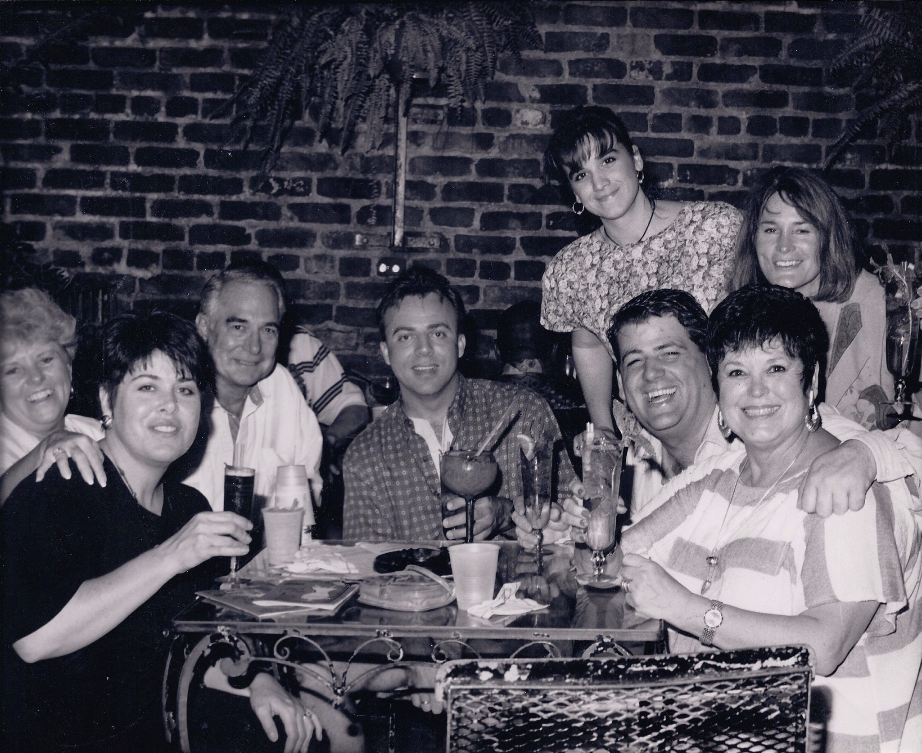
1992, The first year George Geary Culinary Tours ventured into New Orleans. Now, 31 years later and hundreds of excited tour goers since we announced our Fall 2023 New Orleans Tour. Join George and his staff in the “Big Easy.” If this is your first time in the crescent city, you will have an unforgettable time. From cooking classes and plantation tours to meals at award-winning restaurants.

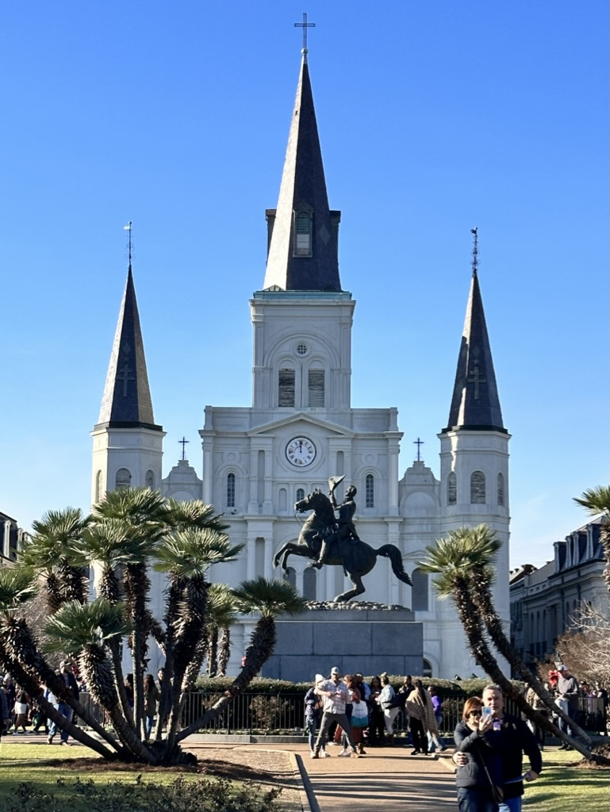

Weekend at a Glance (Subject to change)

Friday October 13th, 2023
Fly into New Orleans Airport (MSY) or drive in if you are local and arrive at our 3-star hotel on Canal Street. Welcome Cocktails at our hotel before we head to our fantastic dinner in the quarter—welcome Drinks and Dinner.
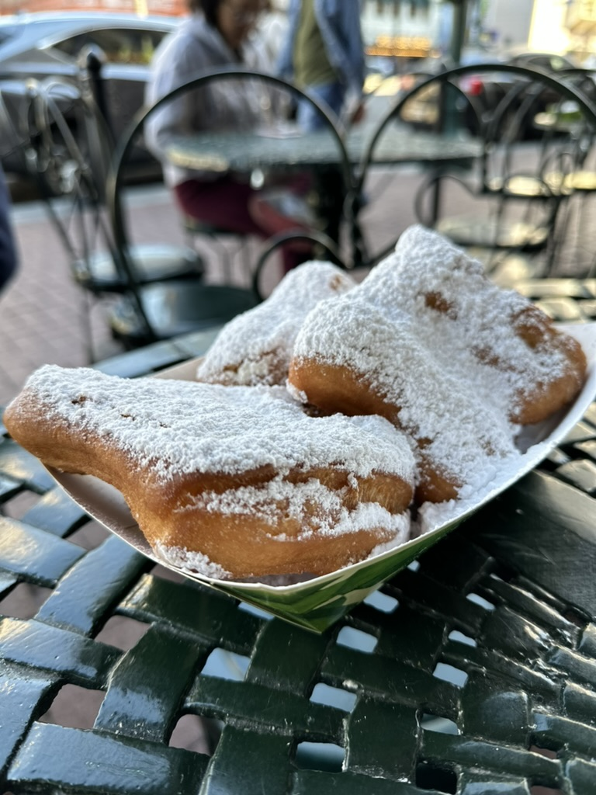
Saturday October 14th, 2023
We will meet for Breakfast will be the World-Famous Café du Monde, then off to our cooking lesson at the New Orleans School of Cooking for our four-course lesson and lunch. After lunch, we will enjoy a private historical architectural walking tour with a guide—plenty of time for shopping in the Warehouse District or Antiquities of Royal Street. Dinner will be on your own to explore the many restaurants of the quarter. Weeks before our tour, a list of great restaurants will be sent so you can reserve it before arrival: Breakfast and Lunch.

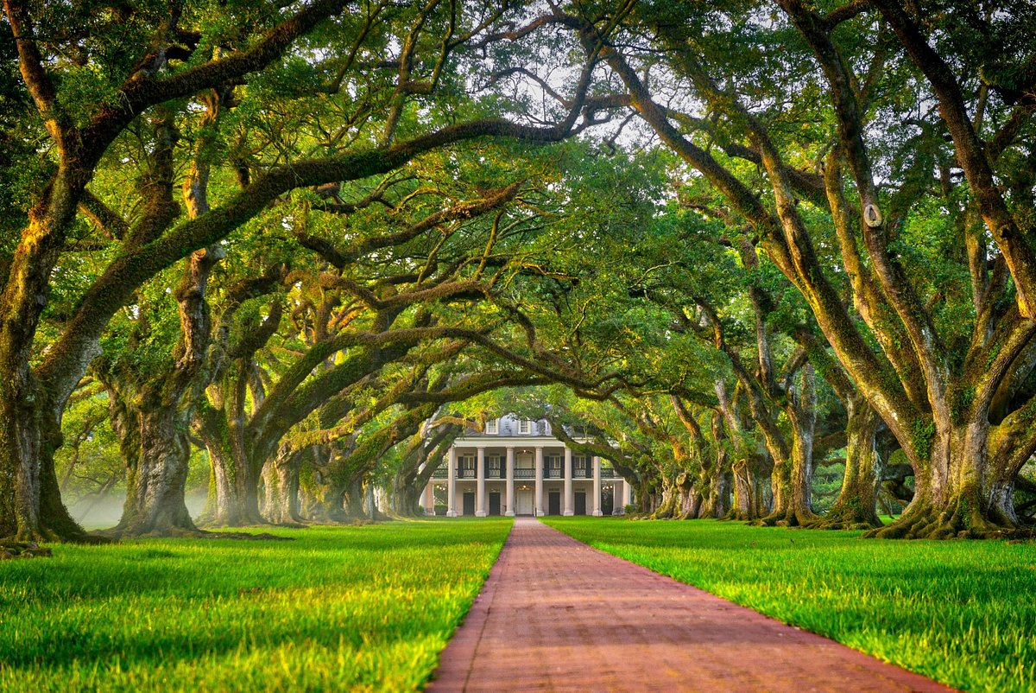
Sunday October 15th, 2023
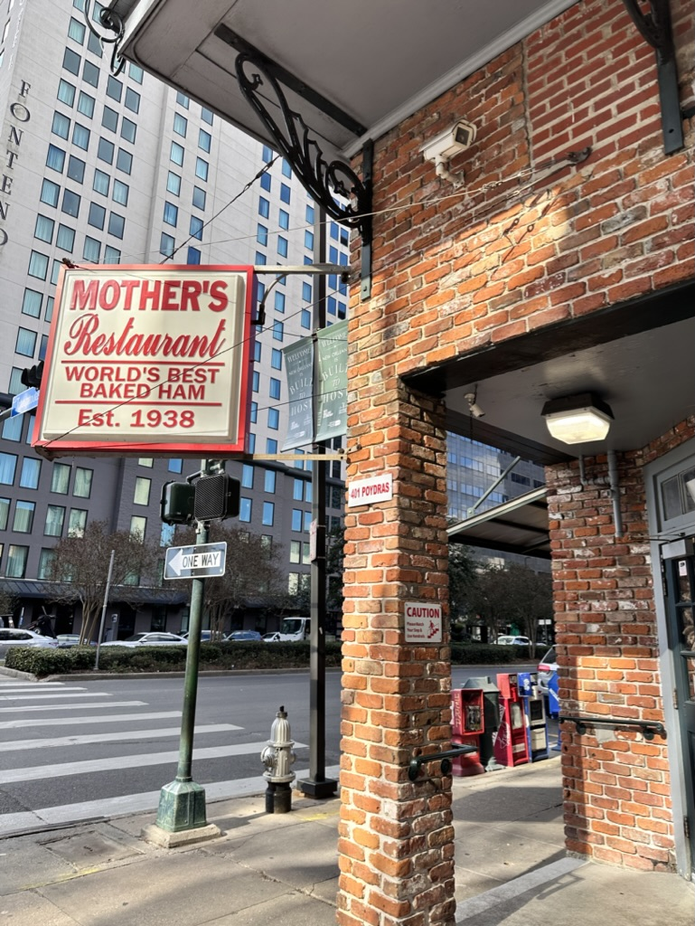
Meeting at Mother’s Restaurant for one of the best places for breakfast, known for its ham, before boarding our motor coach for a city tour, Garden district tour of the large stately homes, and then out to the plantations to see the southern life of years gone past. To finish our day, we will enjoy a Jazz Cruise on the river with dinner and music.
Late Breakfast, Dinner

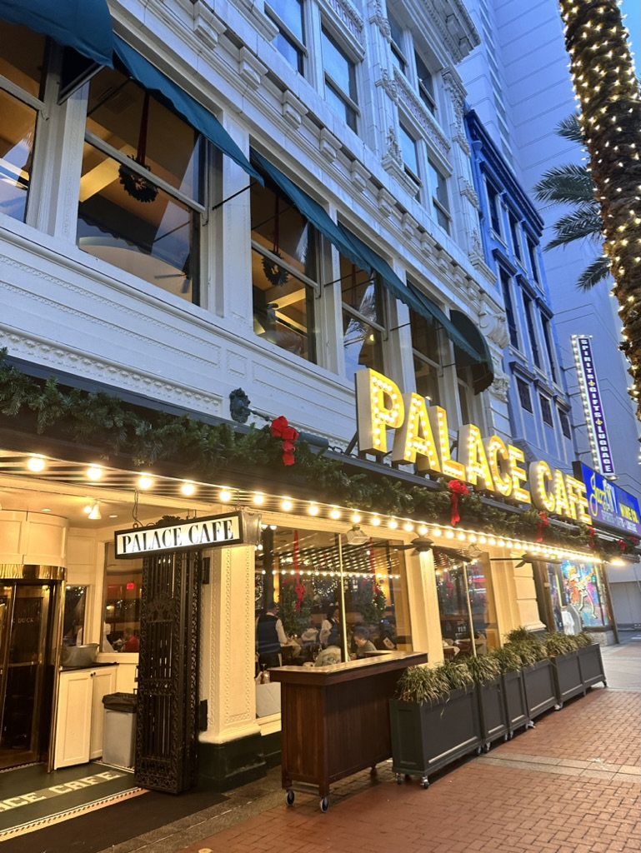
Monday October 16th, 2023
To finish off the exciting weekend. We will have our departure brunch at Brennan’s—home of the Banana’s Foster. Eating in the historic restaurant of the Brennan Family will make memories to last a lifetime. Departures to MSY should be after 2 pm.
Brunch.

Tour Details: Everything listed in the brochure, and more is included in your tour. What’s not included: A few meals, snacks, spending money, travel to and from New Orleans, and insurance. This tour has walking and stairs, so you must be mobile to attend.
All lodging is in a four-star chain hotel. Double or King beds available. Our groups have ranged from honeymoon couples to mother & daughters to best friends and all ages.

Email George Geary Tours at ggeary@aol.com to check availability before sending your deposits as it fills up quickly.

Any questions feel free to contact George at ggeary@aol.com ☏at 951.454.2207

