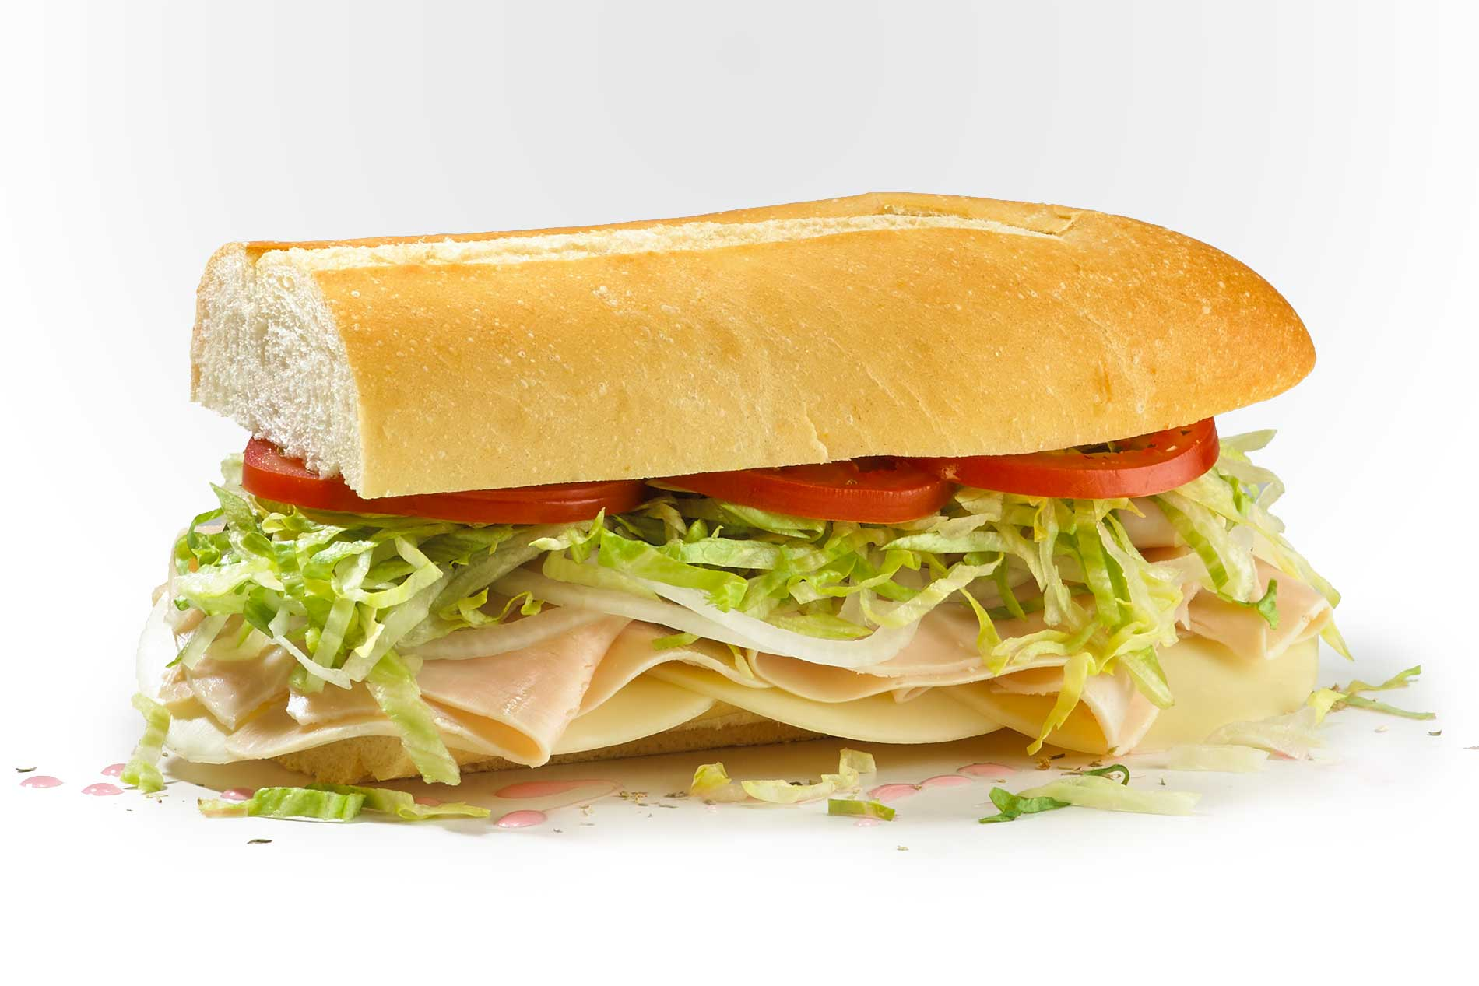

Jersey Mikes: #7: Turkey Provolone Mini (Meal) $12.45
Sandwich (Mini)
Bag of chips
12-oz drink

Sandwich:
6-inch bread .67
Provolone cheese 2 ounces .30
Turkey 3 ounces 2.00
Tomato slices 3 .22
Lettuce .34
Oil/vinegar .13

Bag of Chips .69
Drink .48

Total: “Make it Your Own” $4.83

Savings $7.62

