George Geary Culinary Adventures
The South of France Tour ~ Walking in Julia’s Steps
April 28th -May 4th, 2024
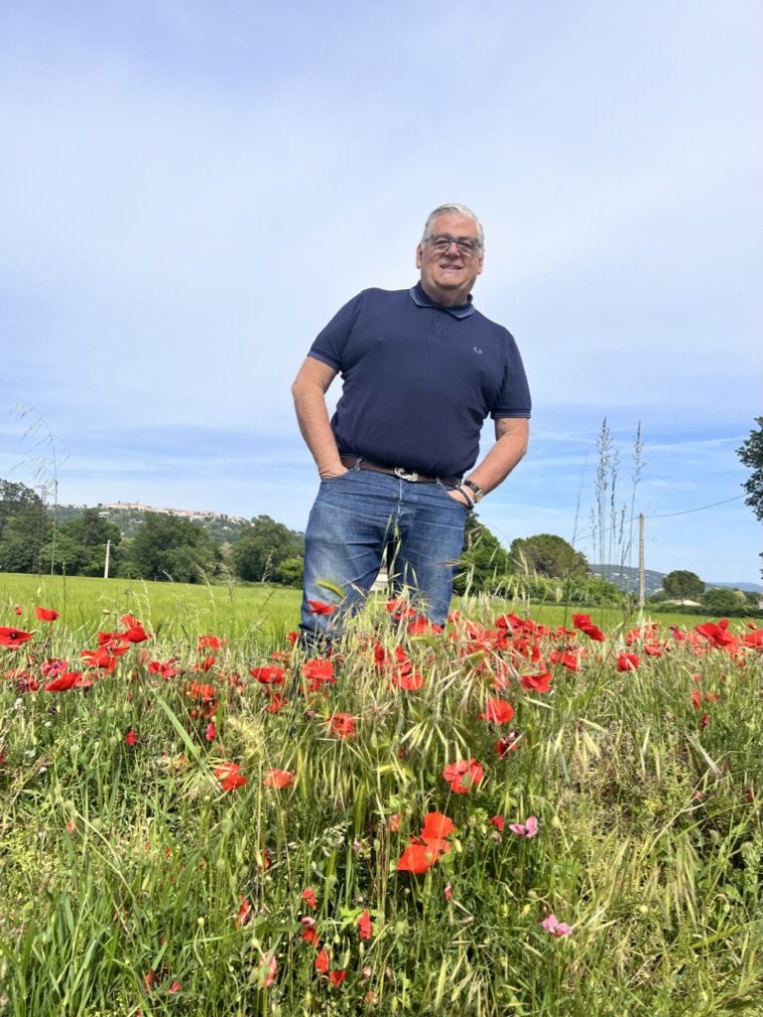
Tour per person: $4950.
Due at Booking: $2950.
No refunds, fully non-refundable.
Remainder $2000. due: February 1st, 2024

Introduction:
If this is your first time traveling abroad or your hundredth, George Geary Multi-Award (Frommers 2012 Tour Company of the Year & IACP Culinary Tour Operator of the Year) Winning Tours will make you very comfortable. With over 37 years of traveling on every continent, GGT is there every step of the way. Small group, so you get the personal service you deserve.
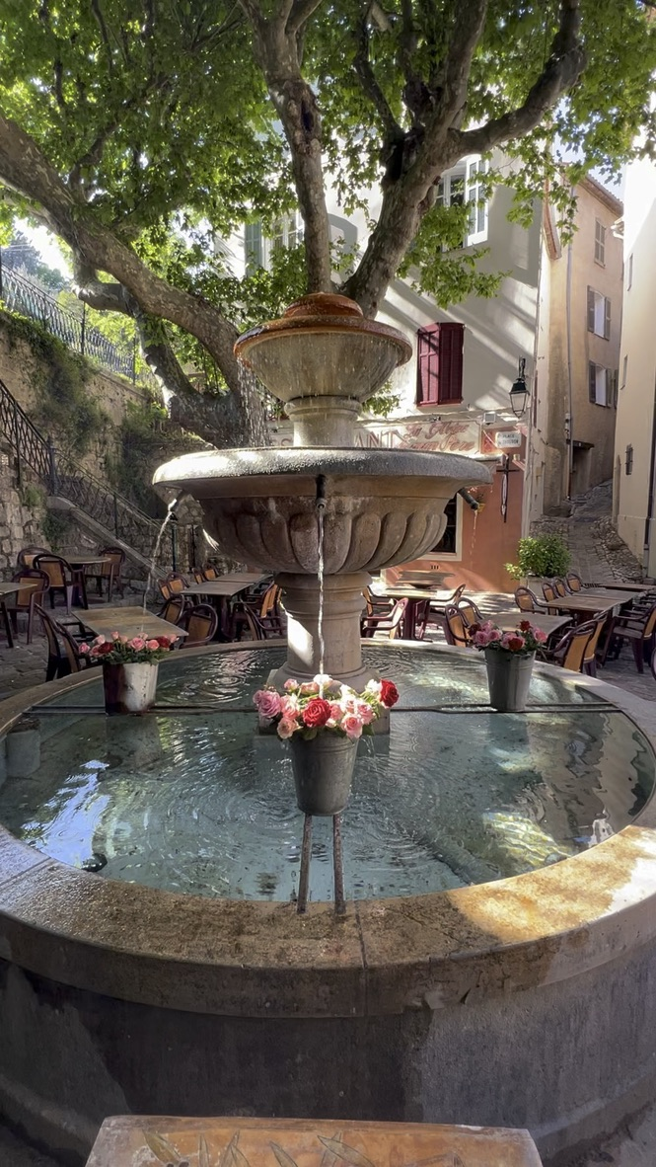
This is the 35th season of conducting food tours in the South of France. For over 20 years, the tour was held at La Pitchoune, the former home of Paul and Julia Child. The house was sold several years later, so GGT moved to a larger villa. Join GGT for a beautiful, unforgettable week in Provencal. You will learn the customs and flavors of the French countryside; from markets, artisan food companies, and everywhere in between. This tour sells out FAST every year. We only offer it once, and every year we change it up! (Last year, we had many repeat guests!) Please think about joining us.

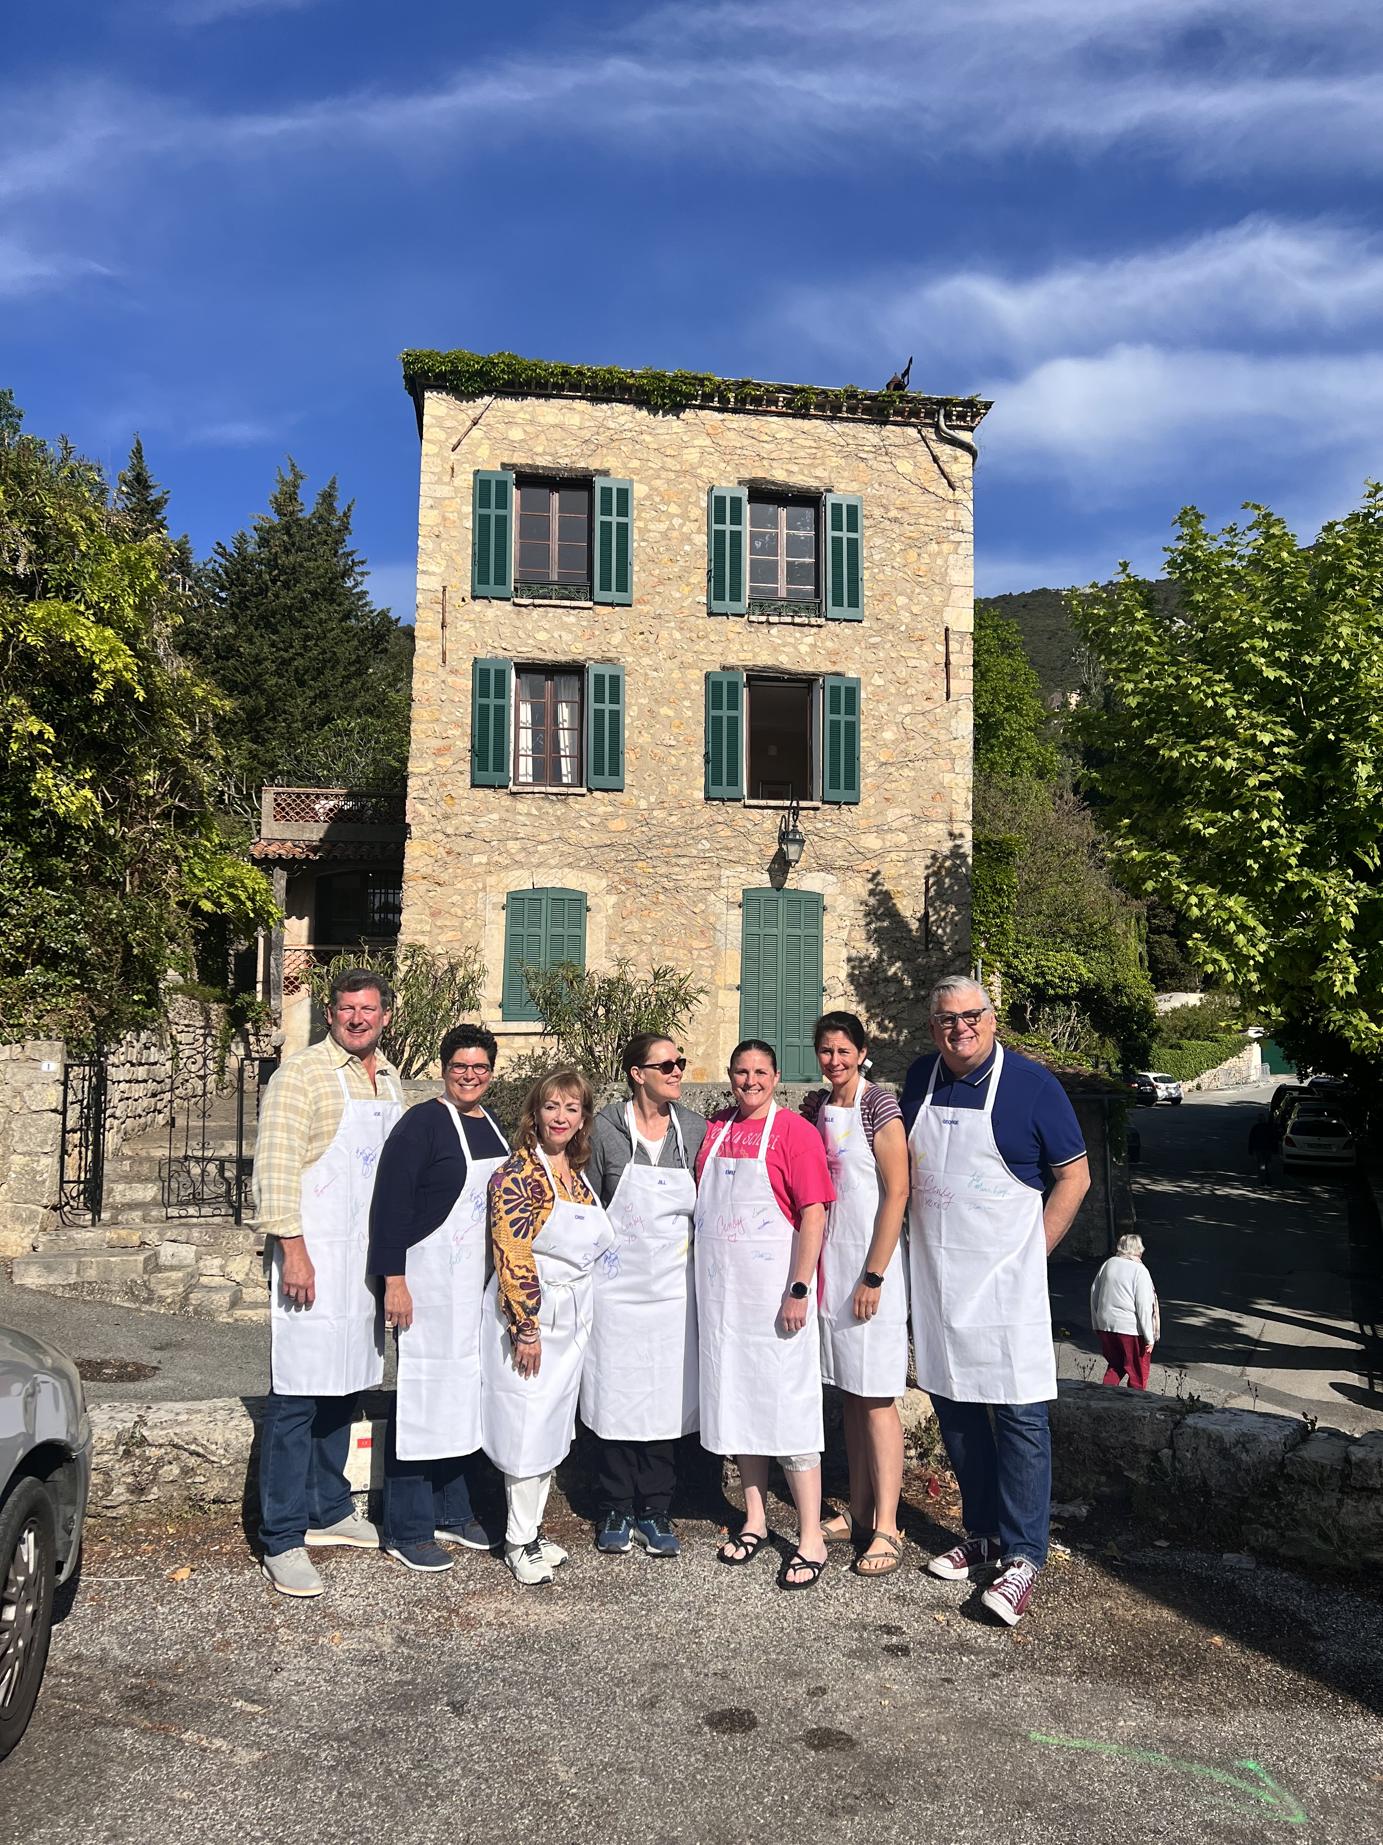
Location/Transportation Details: Arrive at Nice/Cannes (NCE) Airport with a personalized pickup by George Geary Tours. (No worry about a car rental). You will be transported through the beautiful highways of France overlooking the Mediterranean Sea through country roads and villages to the medieval town of Seilians, where we will make our home for the week. Accommodations are in a 17th-century stone villa. Updated for today’s traveler. No need to pack and unpack; we use Seilians as our home base for the week. Two rooms share a bathroom on every floor.

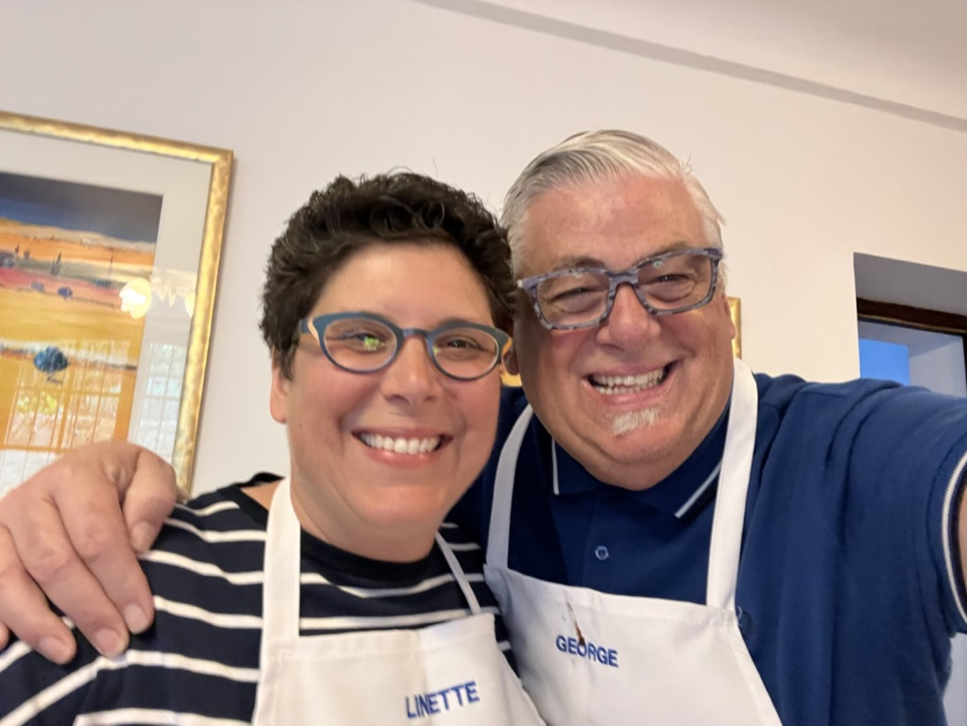
Week at a Glance: (Subject to change) Daily: Waking up every morning to hear village church bells and the birds singing. We will serve a French continental breakfast daily. Fresh crusty croissants to seeded loaves of bread from the village bakery, Orange juice, homemade jams, French butter, coffee & tea.

Sunday Night: Welcome Aperitifs and Dinner. Learn the proper “French” way to enjoy aperitifs overlooking the village. A typical French dinner will be served over wine. We will have introductions and then turn in for the night. D

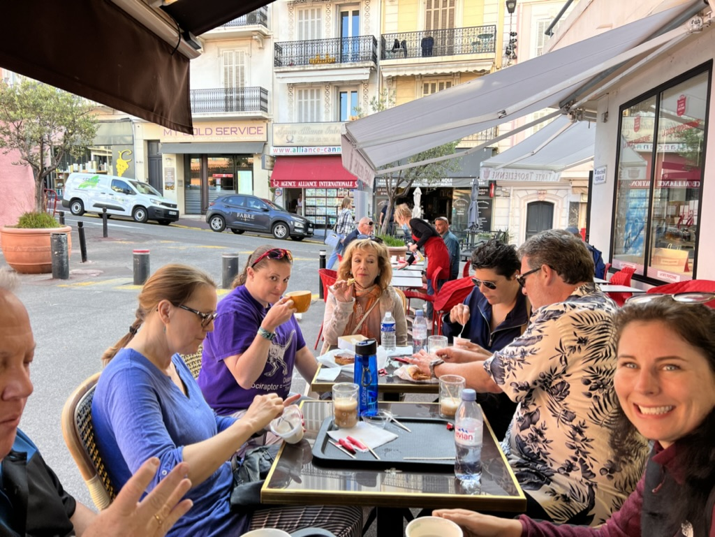
Monday: We will have our first class of three courses, using local and seasonal ingredients, techniques, and recipes to take home with you. After class, we serve our lunch, which we have prepared, and then head into the neighboring villages. We will visit Opio, where Julia would purchase her olive oil and herbs. Then up to the Alps to visit an artisan candy factory that produces Rose Petal jams and decadent confections. Dinner on the way home will be a stop for a light dinner from one of the specialties of the region. (Stone Oven Pizza) and even dessert pizza of Poached Pears and Nutella. BLD

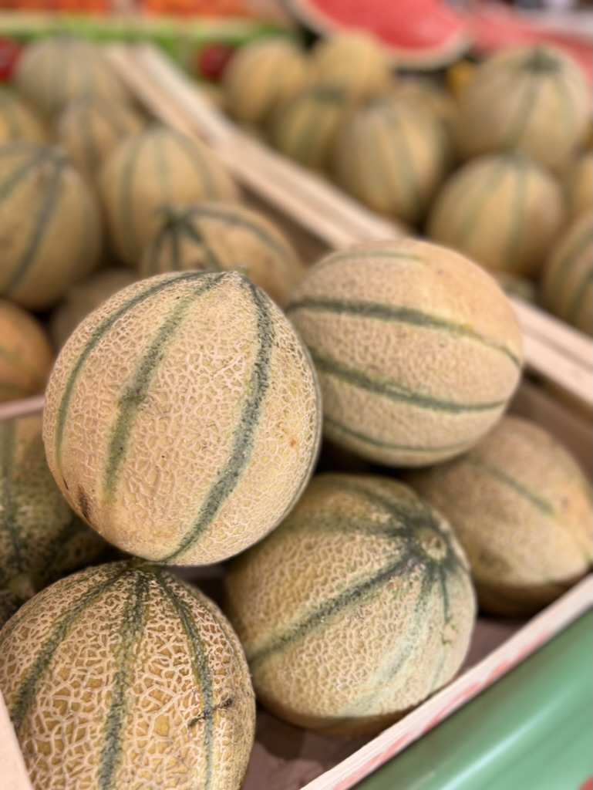
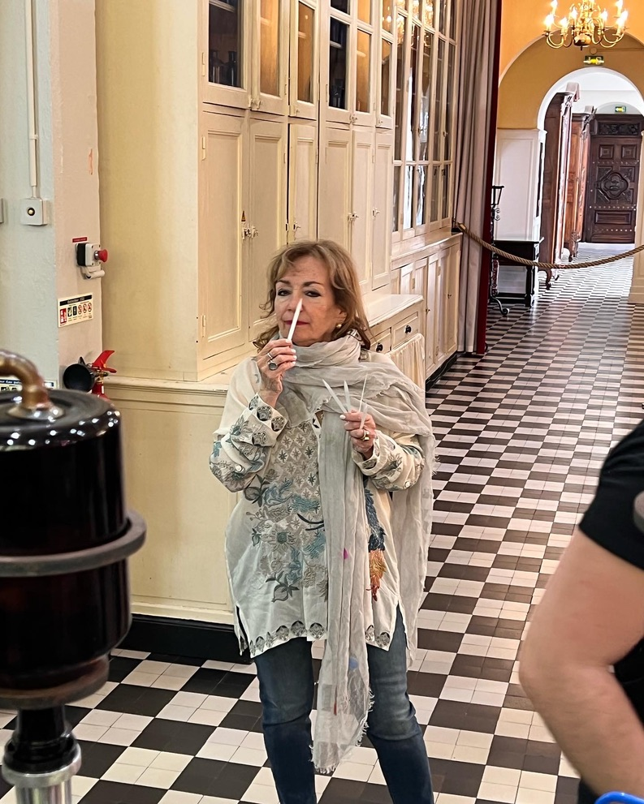
Tuesday: Rose Flower Day! After breakfast, we will head to Antibes and the fishing village for a 3-course class by a French Chef specializing in Roses. After our extended class, we will head to the Molinard perfumery for a tour. The inside was designed by Gustoff Eiffel (pre-Eiffel Tower). We then will learn to use our noses to createourr very own perfume to take home. Dinner is on your own in our village. BL
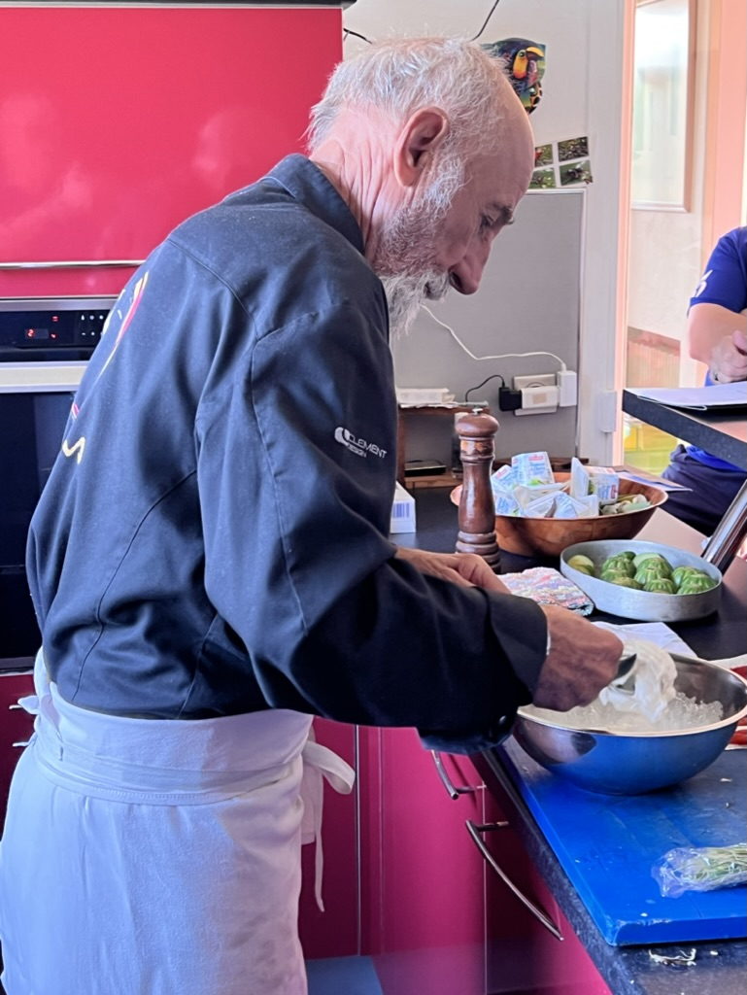
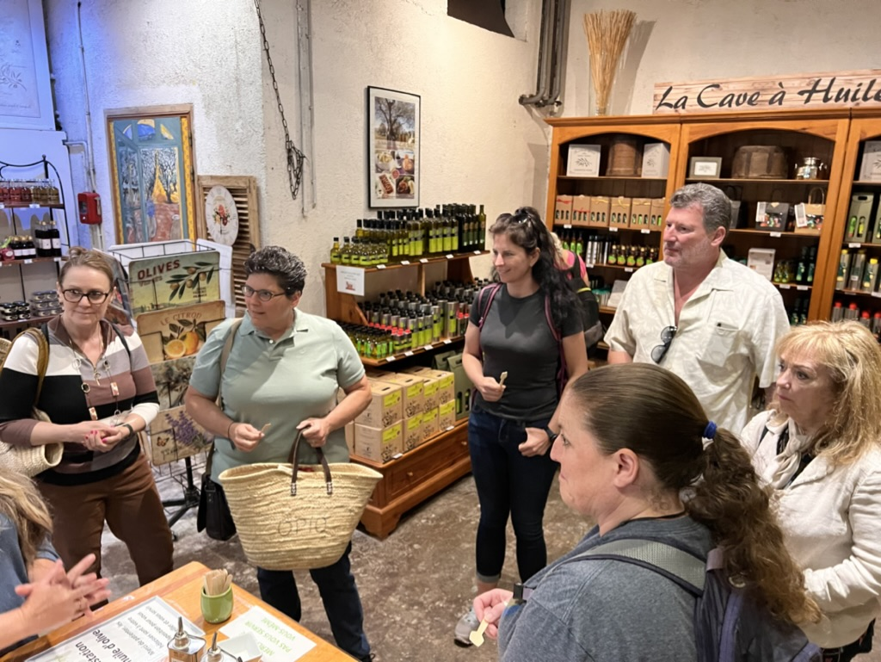
Wednesday: We will get up early to have breakfast with local chefs at the Forville open market in Cannes. A three-hour walking tour of the market in detail with tastings of the local delicacies, from meats and cheeses to textiles. Meet the shop owners and learn the different food and tastes that make the region unique. This is where all the “yachties” of the med shop for their provisions for their high-class mega yachts. You will have plenty of time for shopping, lunch, and touring the Cannes Film Festival area. Tonight, we will have an informative French Cheese class. BD

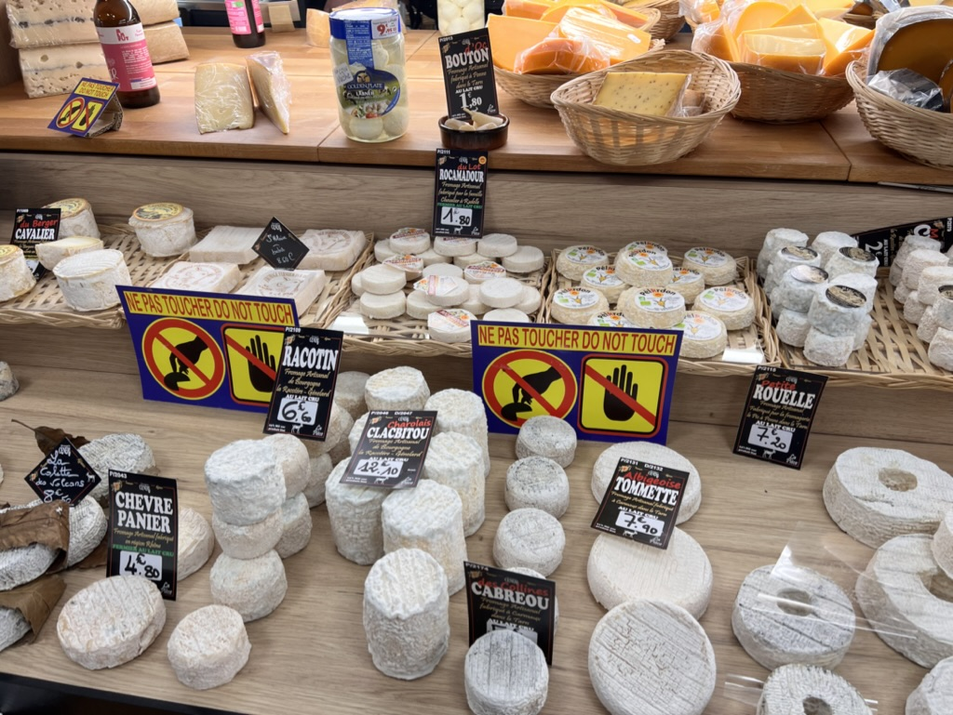
Thursday: After breakfast, we will head out to the private home of a three-star French chef. Visiting his vegetable and herb garden before enjoying a 3-course class in his kitchen. Dinner is on your own in the village or picking up items at the largest market in the area (140 check stands) BL

Friday: A Day in Valbonne and Biot. We will head to the village of Valbonne for one of the most extraordinary markets on the square. This is where in 1995, Kevin Kline and Meg Ryan filmed French Kiss. The market is an exciting market of provincial specialties like Pissaladiere and meats of the region, then off to Biot, the glass-blowing region of beauty. We will tour the craftsman making one-of-a-kind glass pieces you want to take home with you! We will finish our afternoon with a fantastic meal at the village Creperie where the owner will share secrets of crepe making. BL

Saturday: Departing in the morning for the airport transfers.

Tour Details: Everything listed in the brochure, and more is included in your tour. What is not included: A few meals (BLD in bold are included), snacks, spending money, travel to and from Nice, and insurance. This tour has walking and stairs, so you must be mobile to attend. Transportation to and from the airport and the day's excursions are in two smaller cars.

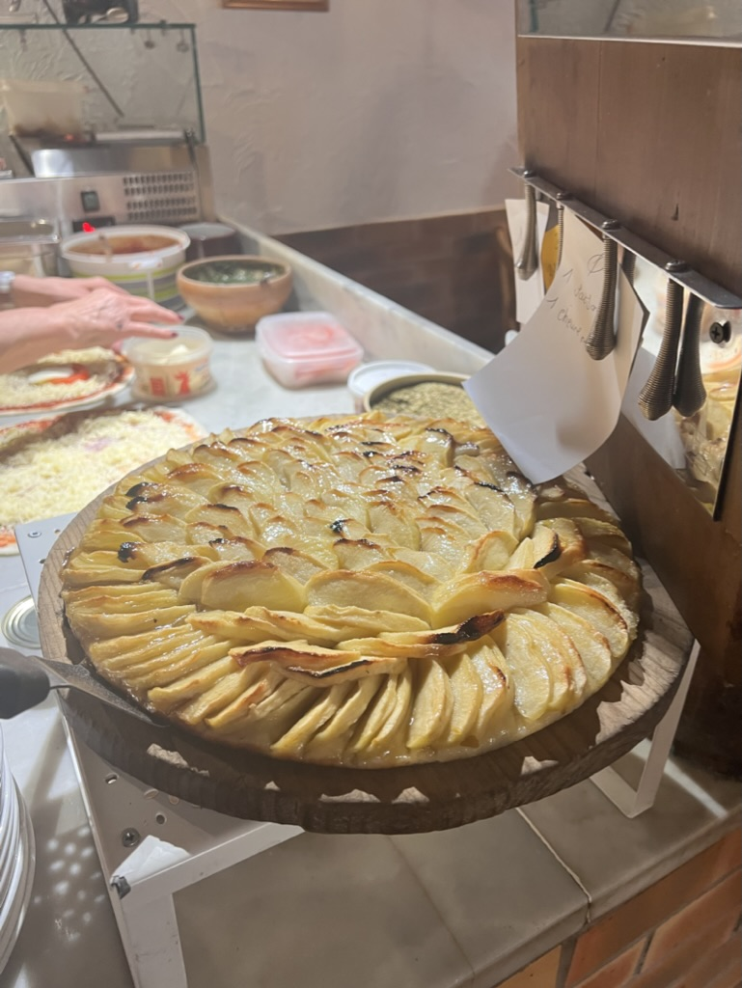
All lodging is on the upper floors of the villa. Rooms are for doubles. We limit the tour to eight. Our groups have ranged from honeymoon couples to mothers & daughters to best friends and all ages.

Email George Geary Tours at ggeary@aol.com to check availability before sending your deposits, as it fills up quickly.

If you have any questions, feel free to contact George at ggeary@aol.com ☏at 951.454.2207

