George Geary Culinary Adventures
Los Angeles Flower Market and Foodie Tour
December 16th, 2023
Early Morning
$130 per person

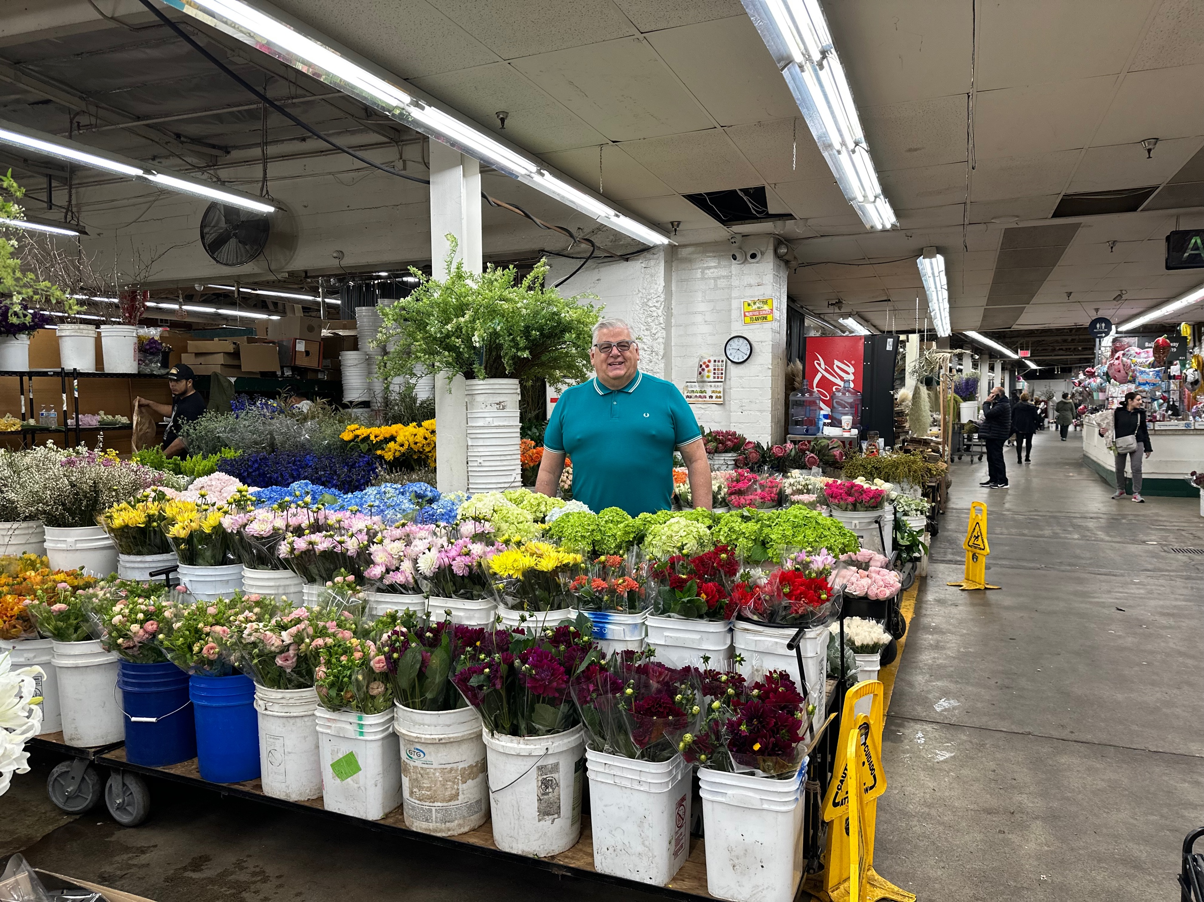
Just in time for the holidays! The Los Angeles Flower Market is bustling, getting ready for the following holidays. This is a chance to enjoy the market with award-winning tour guide George Geary. George has been doing tours of the market for over 30 years. He will show you the best bargains and freshest flowers, and more.

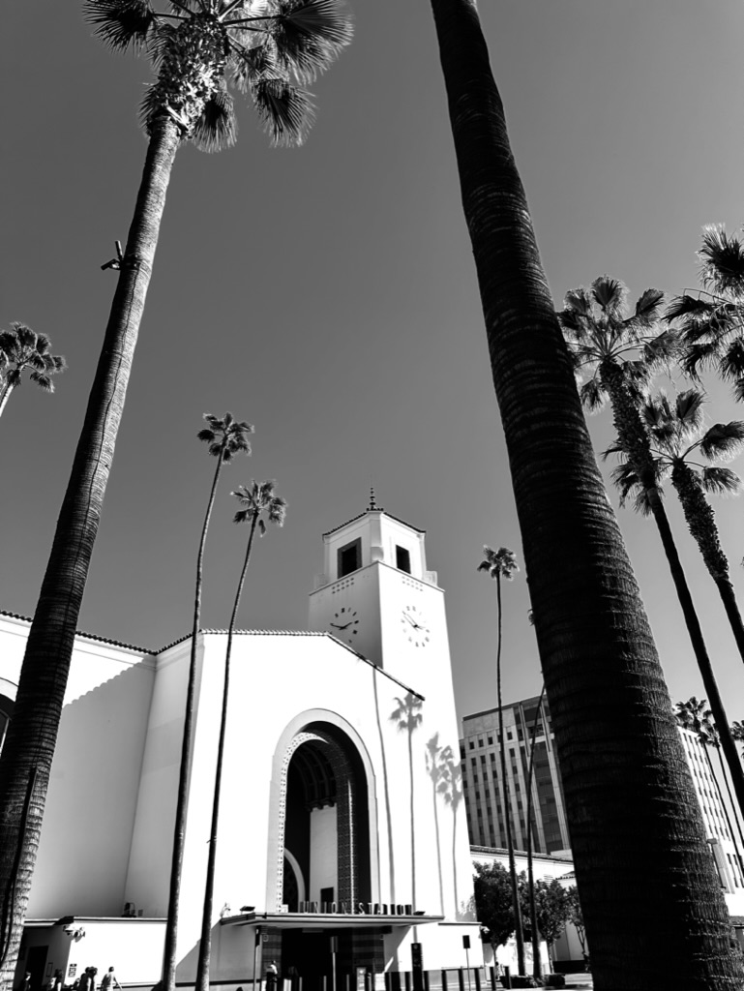
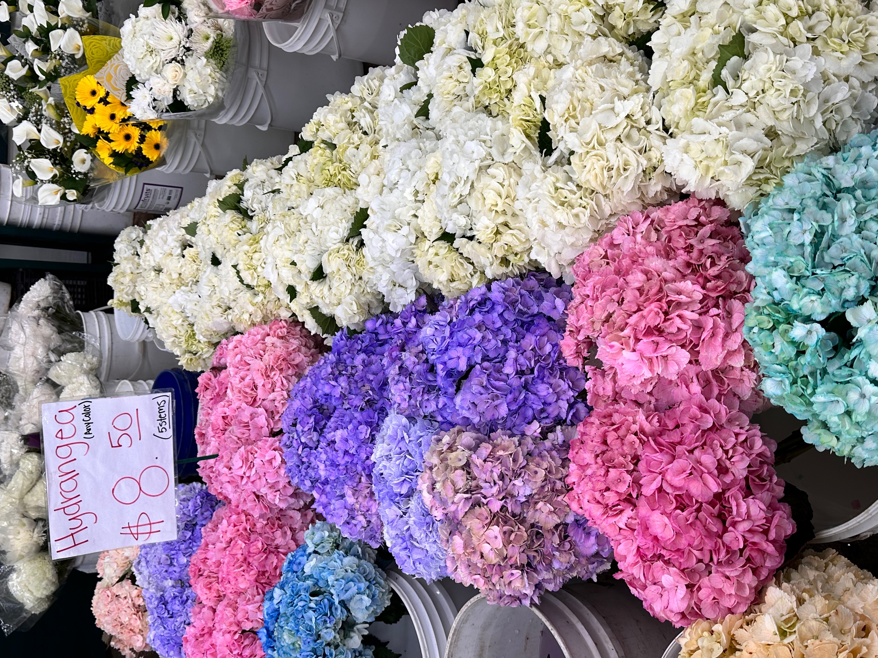
After the reservations, we will see where the pickups should be around the southland. Orange County, Los Angeles, etc., Or just meeting at Union Station Downtown.

Itinerary for the day (Subject to change)

Meeting together for our Flower Markets of Los Angeles adventure. The LA Market is the world’s largest outside of Holland. We will explore the market that usually is open only to wholesalers. Bring cash for purchases. $20 will buy plenty of roses, fresh Christmas wreaths, and more.

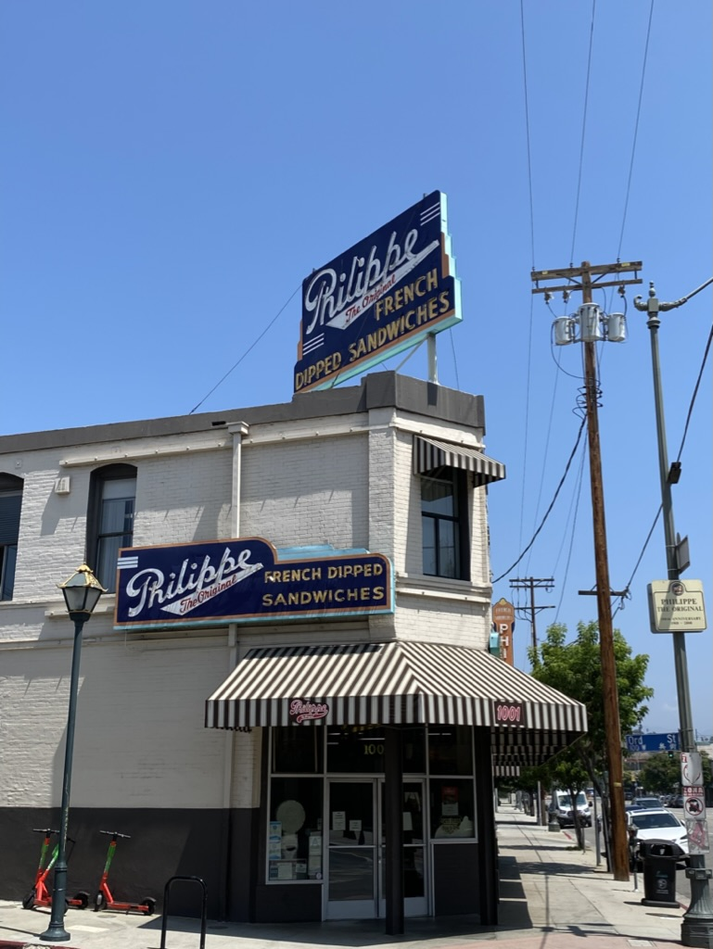
After the market, we will head to breakfast (less than $15pp) at the iconic Philippe The Original; many think of Philippe’s for only their French Dipped sandwiches, but their breakfasts, Biscuits, and Gravy are also world-renowned.

Next, a walk to Union Station for a walking tour of the “Last Great Train Stations” of the country. A Walking tour of the first street of Los Angeles, Olvera Street, with a tasting of the best taquitos since 1934.

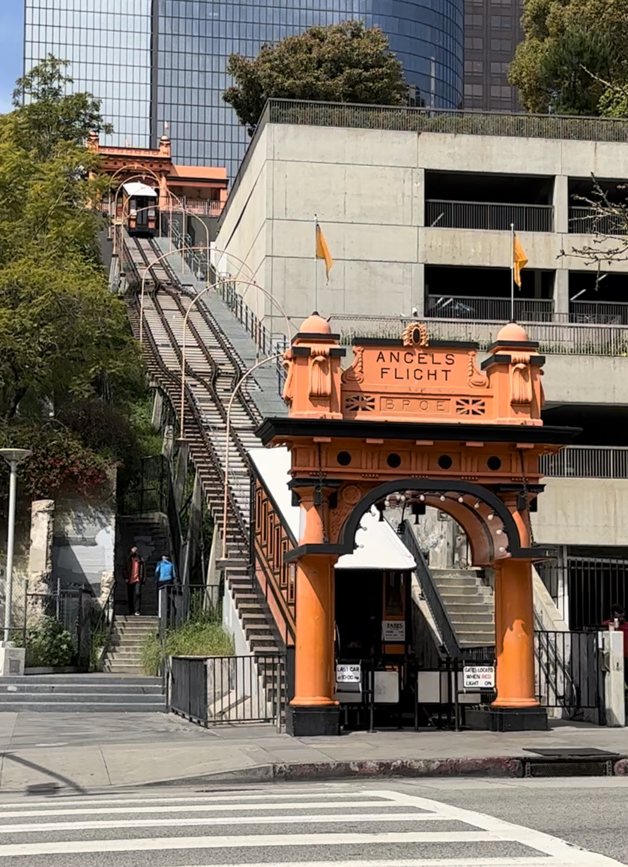
Off to Grand Central Market, filled with food stalls and neon, with a stop at the 1893 Bradbury Building first to gaze at the Victorian architecture and a ride on the 1901 Angels Flight before departing back to our home base with our treasures and memories.

Tour Details: Everything listed, and more are included in your tour. This tour has walking and stairs, so you must be mobile to attend. Transportation to and from the locations will be provided.

Email George Geary Tours at ggeary@aol.com to check for availability; a link will be provided for reservations. If you have any questions, feel free to contact George at ggeary@aol.com ☏at 951.454.2207

